Environment Setup Create A Flask Project

|  |  |
| --- | --- |
| **TEAM ID** | **PNT2022TMID30108** |
| **PROJECT NAME** | **Skill/ Job Recommender Application** |
| **DATE** | **01 NOVEMBER 2022** |
| **STEPS** | **Coding and Install process** |

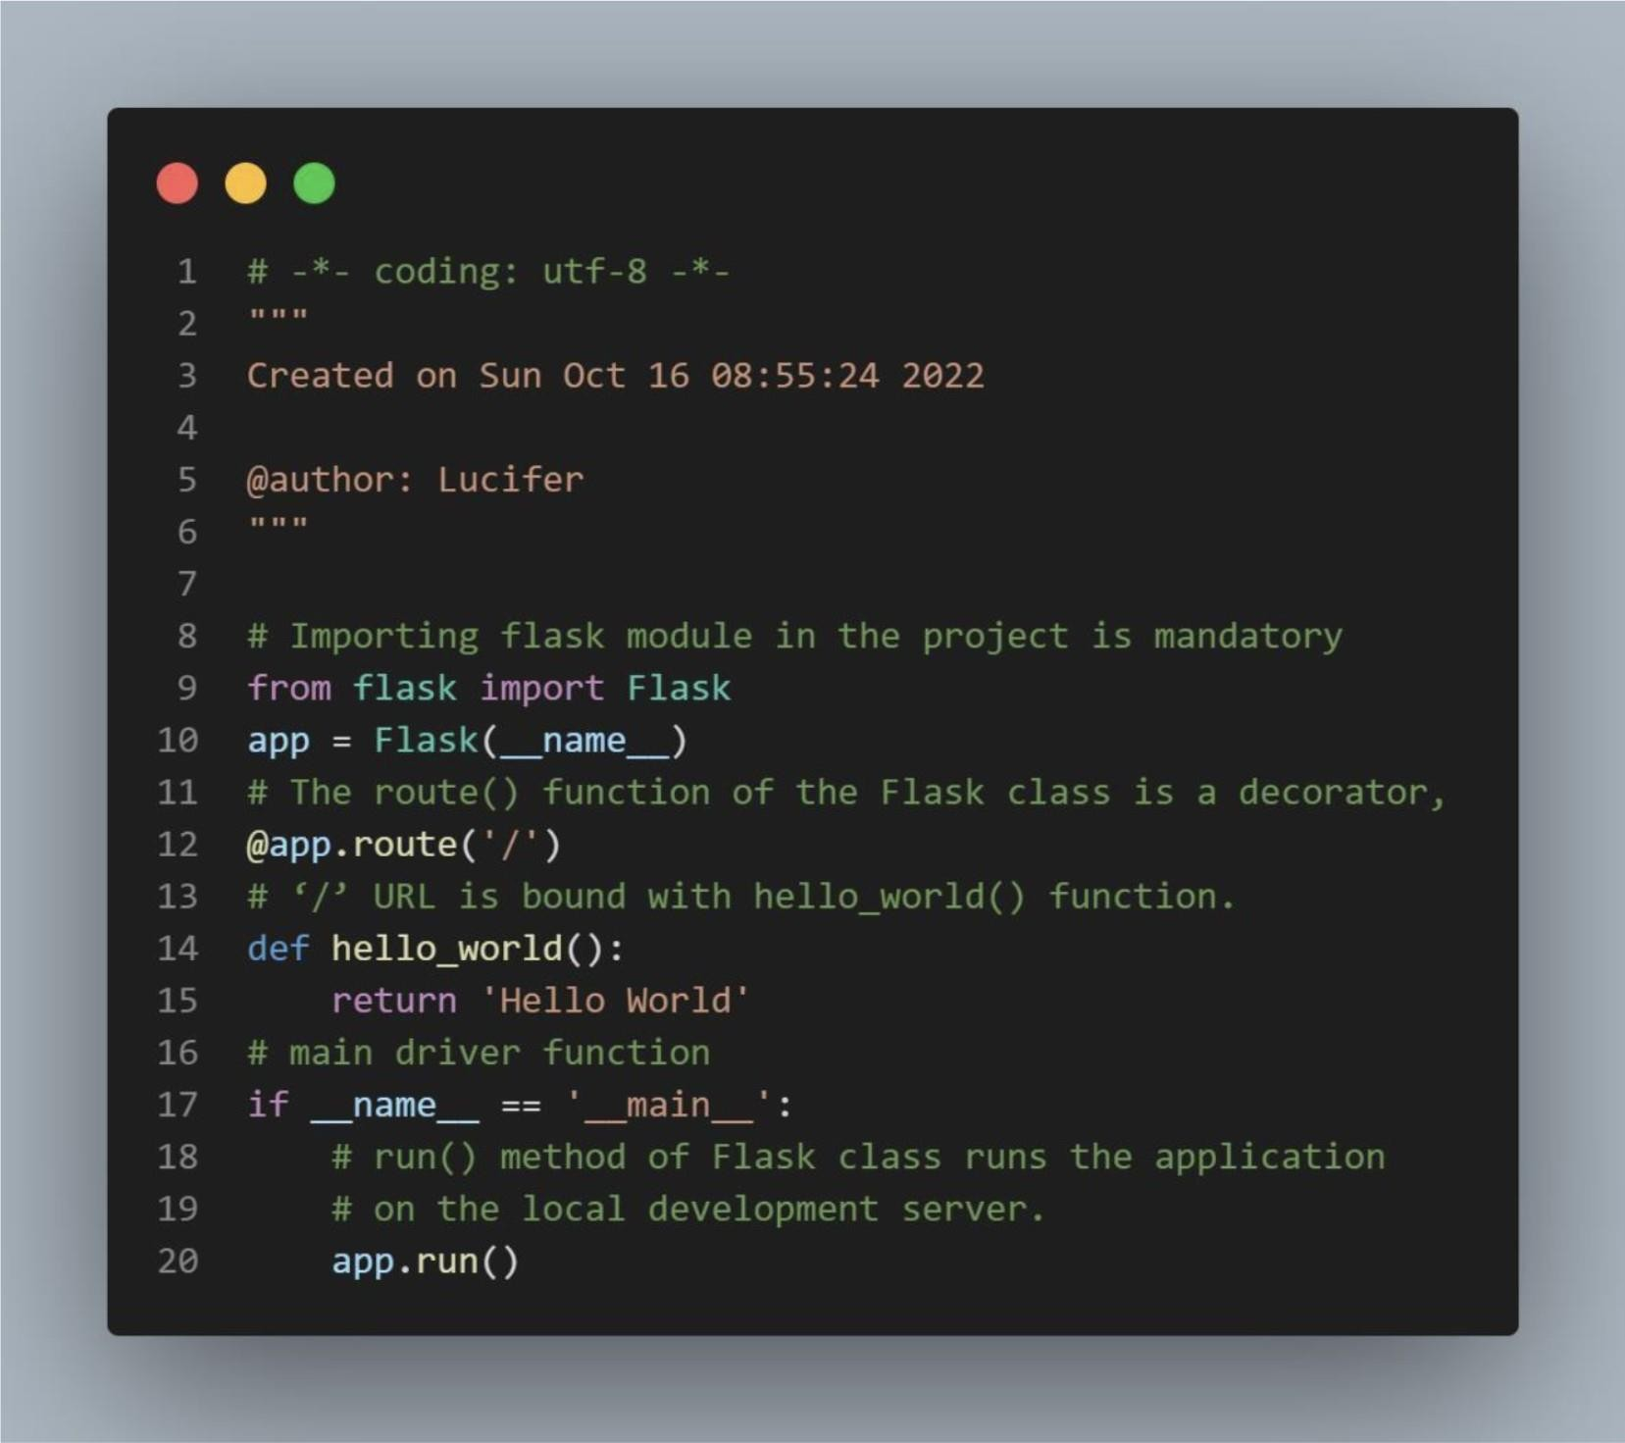CODE:

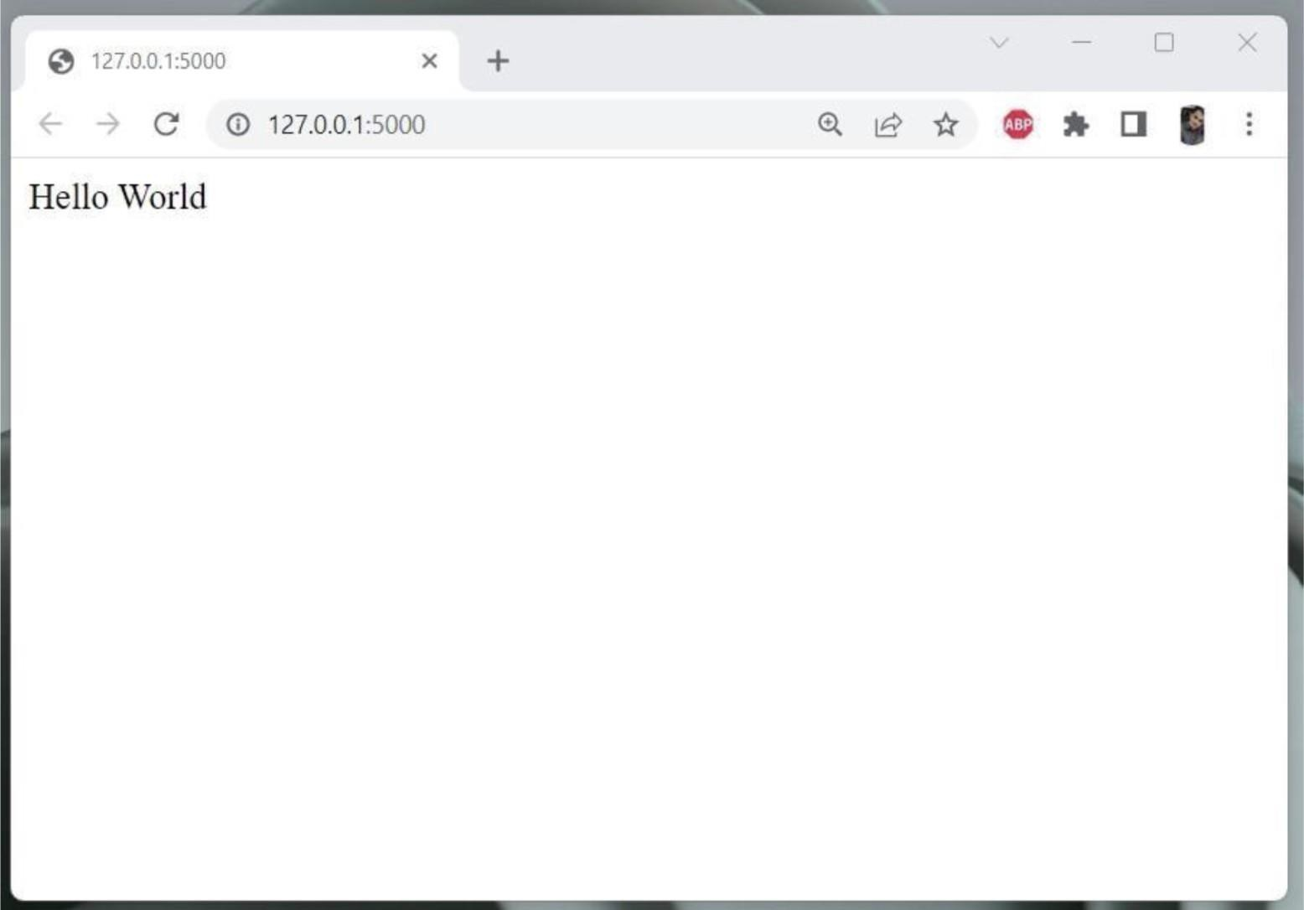

Installation process

